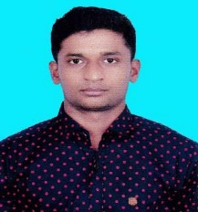 Resume

Of

Md. Abdullah AL Mamun

MAILING ADDRESS :

Md.Abdullah Al Mamun

Daulatpur,Kushtia

Contract No: 01703561759

Email: [mamunreza497@gmail.com](mailto:mamunreza497@gmail.com)

CAREER OBJECT :

To make life challenging through a creative and competitive environment where I have the opportunity to assert strong sense of responsibility to know about the real world laid ahead of me.

**PERSONAL INFORMATION**:

Name : Md. Abdullah Al Mamun

Father’s Name : Md. Bablu Hossen

Mother’s Name : Mst. Parvina Khatun

Present Address : Vill.-Parshitly, P.O.-Baragangdia,

U.P.-Daulatpur, Dist.- Kushtia

Present Address : Sardarpara,Cadet College,Rangpur Sadar,Rangpur

Date of Birth : 25 November 2001

Nationality : Bangladeshi

Religion : Islam

Marital Status : Unmarried

Blood Group : AB+

**EDUCATIONAL QUALIFICATION:**

Graduation : Pending ( 3 rd year)

Department : History & Archaeology

University : Begum Rokeya university ,Rangpur

**Higher Secondary Certificate (H.S.C)**

College : Kushtia Govt.Central College

Department : Humanities

Passing year : 2019

Board : Jashore

Result : 4.08

**Secondary School Certificate ( S.S.C)**

School : Aria United Secondary School

Department : Science

Passing Year : 2017

Board : Jashore

Result : 4.23